Vũ Đặng Quỳnh Giang
17133015

Module 4 Assignment
The Module 4 Assignment provides experience creating and manipulating materialized views in Oracle. You will create several materialized views and apply the matching process to rewrite several queries using the materialized views.
You will use the Inventory Data Warehouse in the module 4 assignment. Other documents provide details about the Inventory Data Warehouse. The Inventory Data Warehouse design and rows are identical from module 5 in course 2. If you added rows through the data integration assignment in module 5 of course 2, you should remove those rows or just recreate and repopulate the tables.

1. Create Materialized View for 2011 Shipments
Write a CREATE MATERIALIZED VIEW statement according to the following specifications:
- The result should contain the sum of the extended cost, the sum of the quantity, and the count of inventory transactions.
- These calculated amounts should be summarized by the customer vendor key and the date key.
- The result should include only sales shipment transactions (transaction type 5) for the year 2011.
- The materialized view should not contain subtotals that are created by the CUBE and the ROLLUP keywords.
- To make the peer assessment easier, you should name your materialized view “SalesByVendorDateKeyMV2011”.

create view salesbyvendordatekeymv2011
with schemabinding
as
select custvendorkey, f.datekey,
sum(isnull(extcost,0)) as total_cost,
sum(isnull(quantity,0)) as total_quantity,
count_big(*) as total_transactions
from dbo.inventory_fact f join dbo.date_dim d on f.datekey = d.datekey
where transtypekey = 5 and calyear = 2011
group by custvendorkey, f.datekey;

go

create unique clustered index uix_salesbyvendordatekeymv2011_custvendorkey_datekey
on salesbyvendordatekeymv2011(custvendorkey, datekey)

go

select *
from salesbyvendordatekeymv2011

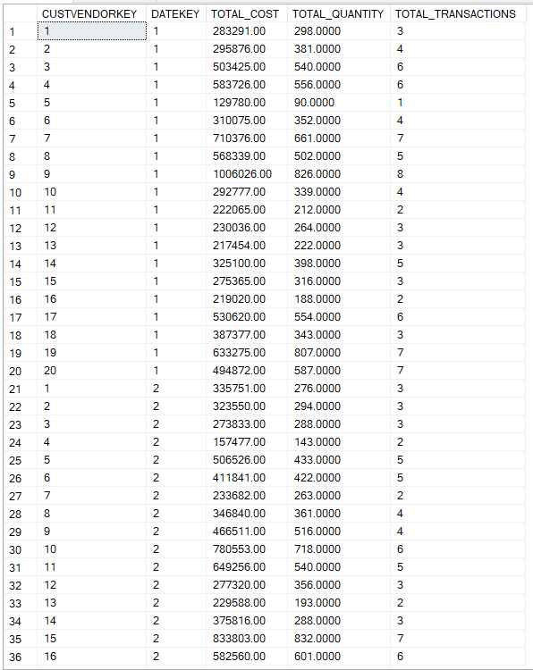
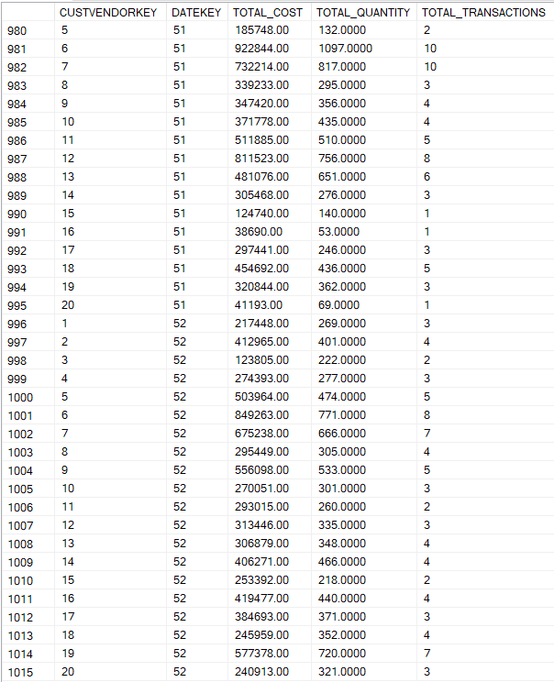

2. Create Materialized View for 2012 Shipments
Write a CREATE MATERIALIZED VIEW statement according to the following specifications:
- The result should contain the sum of the extended cost, the sum of the quantity, and the count of inventory transactions.
- These calculated amounts should be summarized by the customer vendor key and the date key.
- The result should include only sales shipment transactions (transaction type 5) for the year 2012.
- The materialized view should not contain subtotals that are created by the CUBE and the ROLLUP keywords.
- To make the peer assessment easier, you should name your materialized view “SalesByVendorDateKeyMV2012”.
create view salesbyvendordatekeymv2012
with schemabinding
as
select custvendorkey, f.datekey,
sum(isnull(extcost,0)) as total_cost,
sum(isnull(quantity,0)) as total_quantity,
count_big(*) as total_transactions
from dbo.inventory_fact f join dbo.date_dim d on f.datekey = d.datekey
where transtypekey = 5 and calyear = 2012
group by custvendorkey, f.datekey;
go

create unique clustered index uix_salesbyvendordatekeymv2012_custvendorkey_datekey
on salesbyvendordatekeymv2012(custvendorkey, datekey)

go

select *
from salesbyvendordatekeymv2012

3. Rewrite Query 1 of the Module 2 Assignment
Using the materialized views that you created in problems 1 and 2, you should rewrite query 1 from the module 2 assignment. After you submit the module 2 assignment, you will have access to the solution as part of the peer assessment. You should rewrite query 1 using the materialized views to replace the fact table and possibly dimension tables. You should not use a CREATE VIEW statement in your solution. For ease of reference, here are the requirements for query 1 of the module 2 assignment.
Write an SQL statement to display the sum of the extended cost and the sum of the quantity. The results should include data for shipments (transaction type 5) in calendar year 2011. Summarize the result by calendar month and Address Category Code 1. The result should include the full set of subtotals for every combination of grouped fields.
select calmonth, addrcatcode1,
sum(mv.total_cost) as totalcost,
sum(mv.total_quantity) as totalquantity
from salesbyvendordatekeymv2011 mv join cust_vendor_dim c
on mv.custvendorkey = c.custvendorkey
join date_dim d
on mv.datekey = d.datekey
group by cube(calmonth, addrcatcode1)
order by calmonth, addrcatcode1;
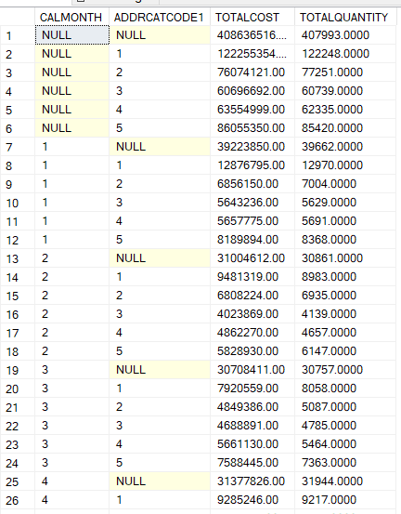
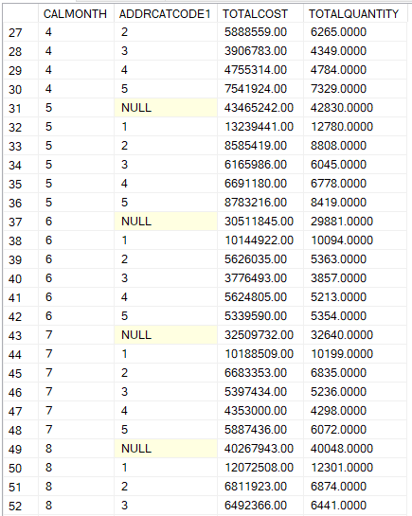
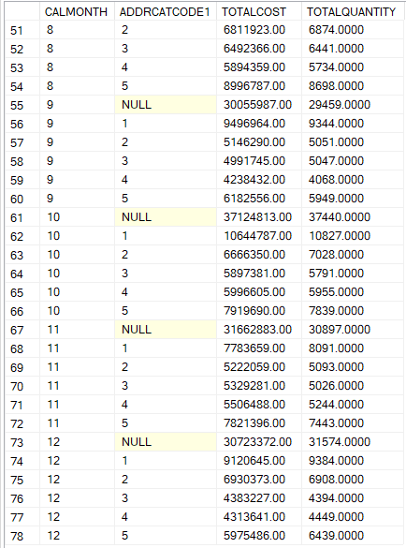

4. Rewrite Query 2 of the Module 2 Assignment
Using the materialized views that you created in problems 1 and 2, you should rewrite query 2 from the module 2 assignment. After you submit the module 2 assignment, you will have access to the solution as part of the peer assessment. You should rewrite query 2 using the materialized views to replace the fact table and possibly dimension tables. You can use either the CUBE or GROUPING SETS operator in your solution. You should not use a CREATE VIEW statement in your solution. For ease of reference, here are the requirements for query 2 of the module 2 assignment.
Write an SQL statement to display the sum of the extended cost and the number of inventory transactions. The results should include data for shipments (transaction type 5) in calendar years 2011 and 2012. Summarize the result by calendar quarter, customer zip code, and customer name. The result should include the grouped columns and the full set of subtotals for every combination of grouped columns.
select calquarter, zip, name,
sum(total_cost) as total_cost,
sum(total_transactions) as total_transactions
from
(
select d.calquarter, c.zip, c.name, total_cost, total_transactions
from salesbyvendordatekeymv2011 mv join date_dim d on mv.datekey = d.datekey
join cust_vendor_dim c on mv.custvendorkey = c.custvendorkey
union
select d.calquarter, c.zip, c.name, total_cost, total_transactions
from salesbyvendordatekeymv2012 mv join date_dim d on mv.datekey = d.datekey
join cust_vendor_dim c on mv.custvendorkey = c.custvendorkey
) as tableforviewing
group by cube (calquarter, zip, name)
order by 1,2,3;
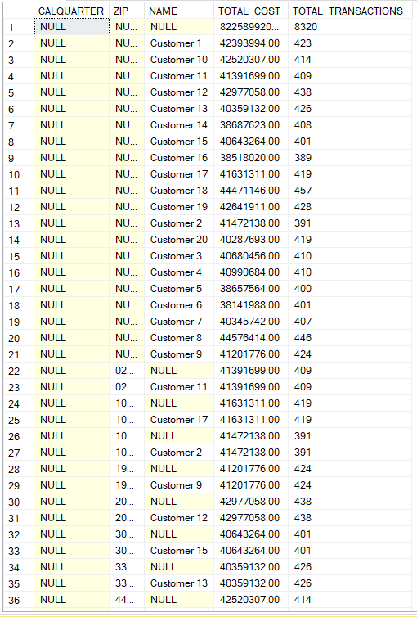
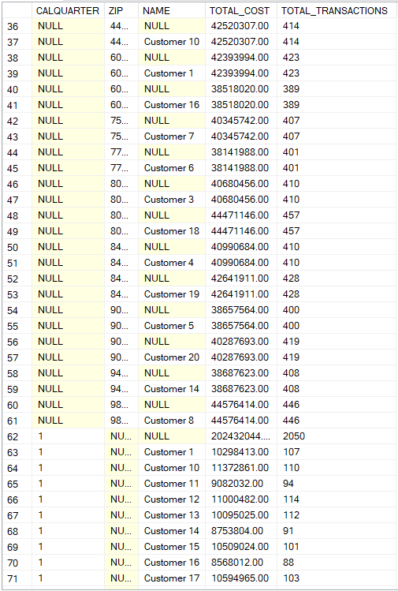
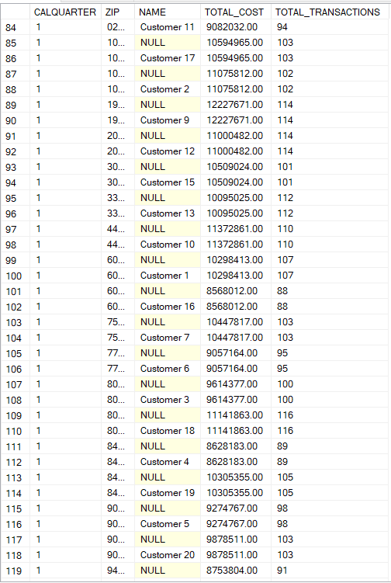
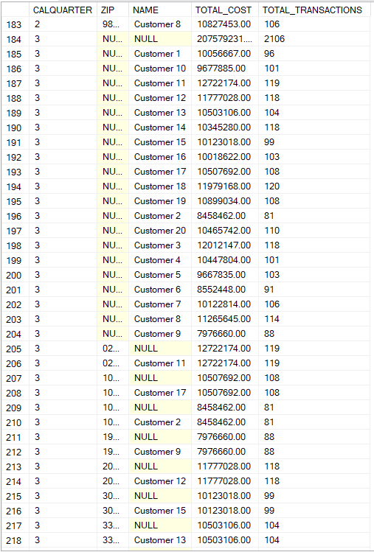
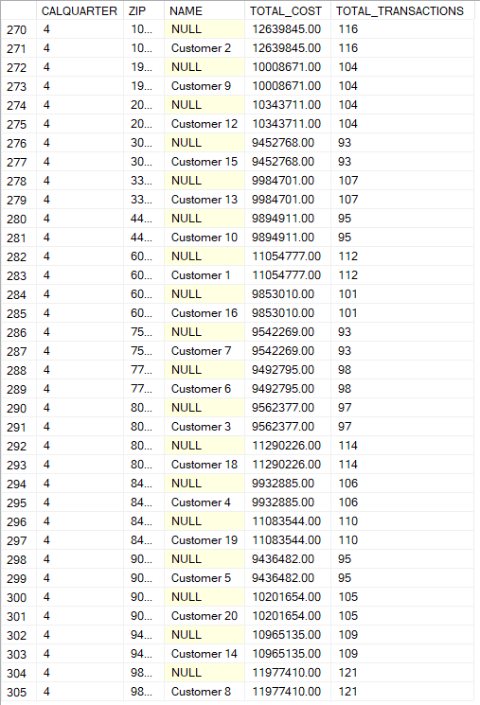

Grading
Your performance will be assessed by a quiz designed to test your understanding of each problem and by evidence of query executions. Since some quiz questions involve execution results, you should execute your statements using the original inventory data warehouse tables.
- You will receive 50% if your documentation contains SQL statements and partial results for each problem. Execution of your SQL statements demonstrates correct syntax.
- The quiz score will provide the other 50% of your grade. The quiz contains questions about the important elements of each problem such as the usage of the correct tables, function, partitioning, and sorting.

Completion
You should upload a file containing your Oracle SQL statements and execution results to the graded item in module 4. For the execution results, you should take a snapshot of the script output window in SQL Developer showing the execution results. For problems 3 and 4, you only need to show the first 10 rows or so of the result. You should paste the execution results after the associated SQL statement.

